Exercise 3: Stored Procedures
Created 2 tables
Accounts Table
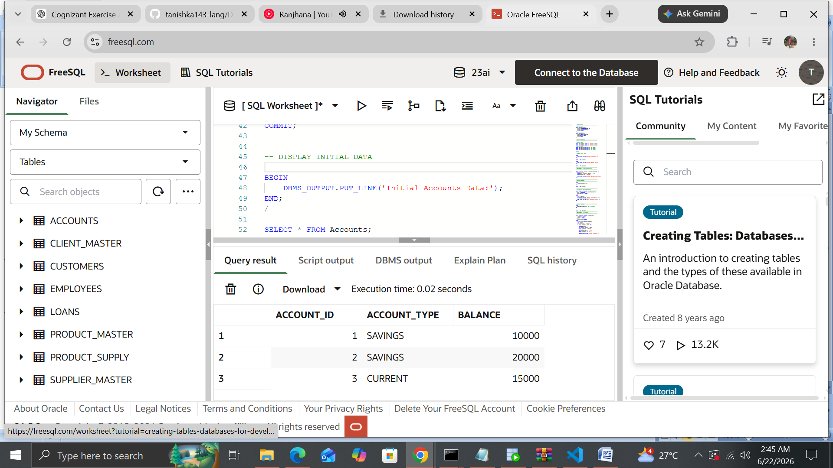
Employees Table
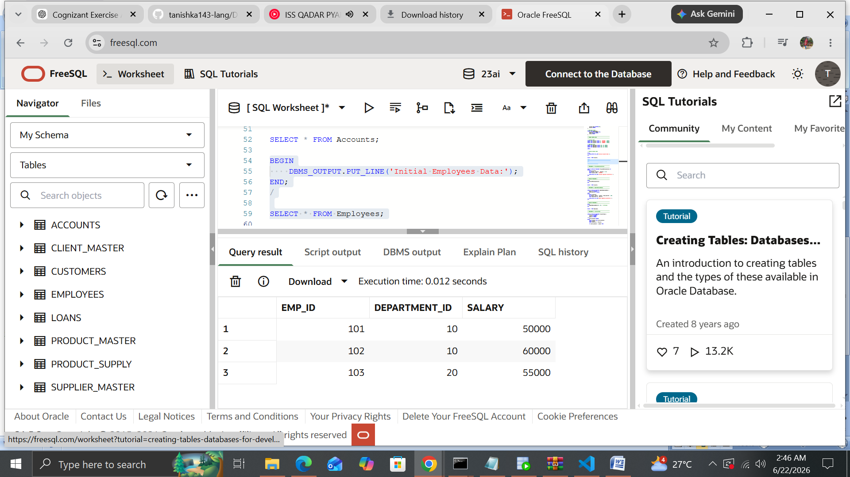

Scenario 1: The bank needs to process monthly interest for all savings accounts.
o Question: Write a stored procedure ProcessMonthlyInterest that calculates and updates the balance of all savings accounts by applying an interest rate of 1% to the current balance.
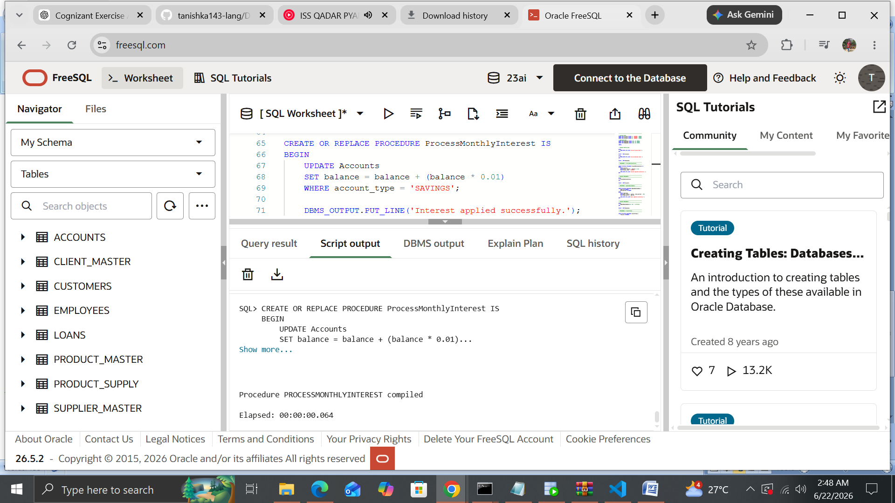
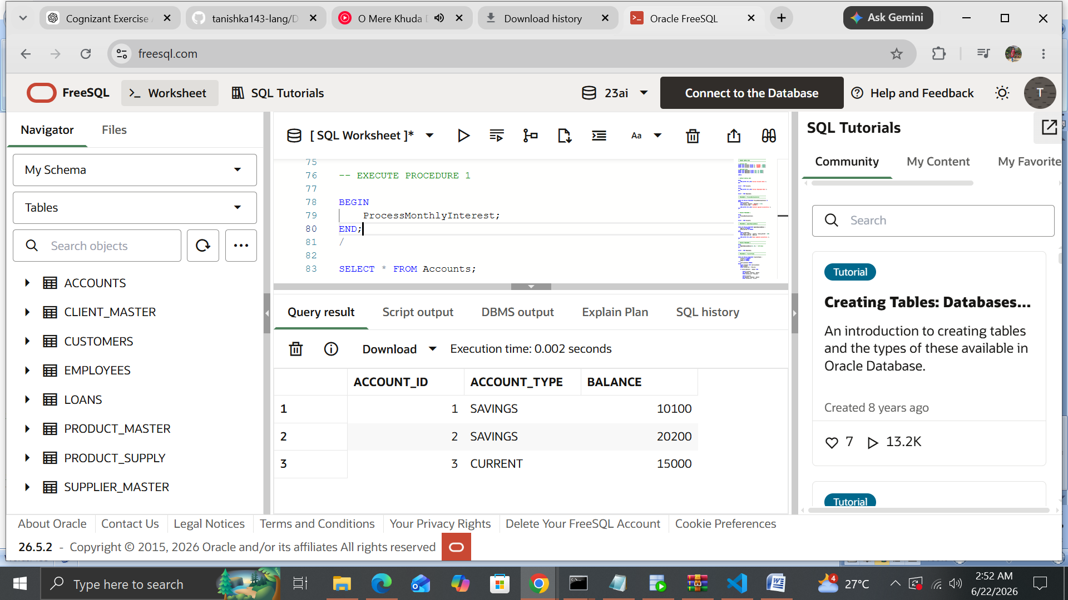

Scenario 2: The bank wants to implement a bonus scheme for employees based on their performance.
o Question: Write a stored procedure UpdateEmployeeBonus that updates the salary of employees in a given department by adding a bonus percentage passed as a parameter.
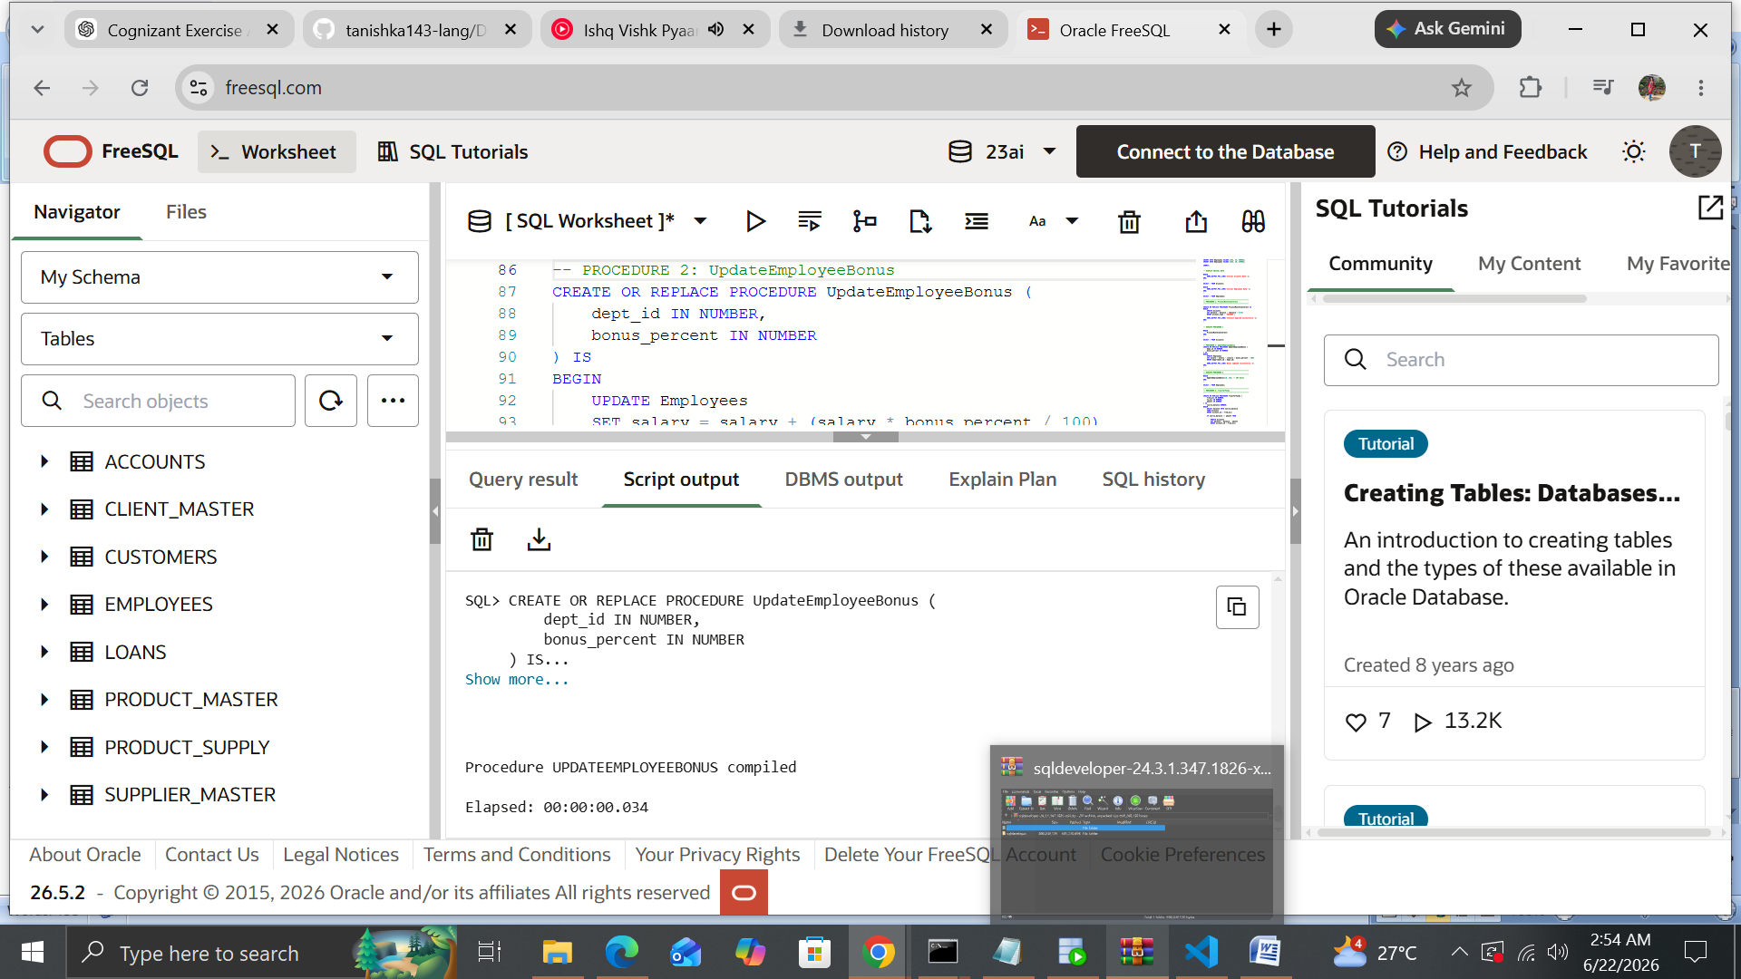
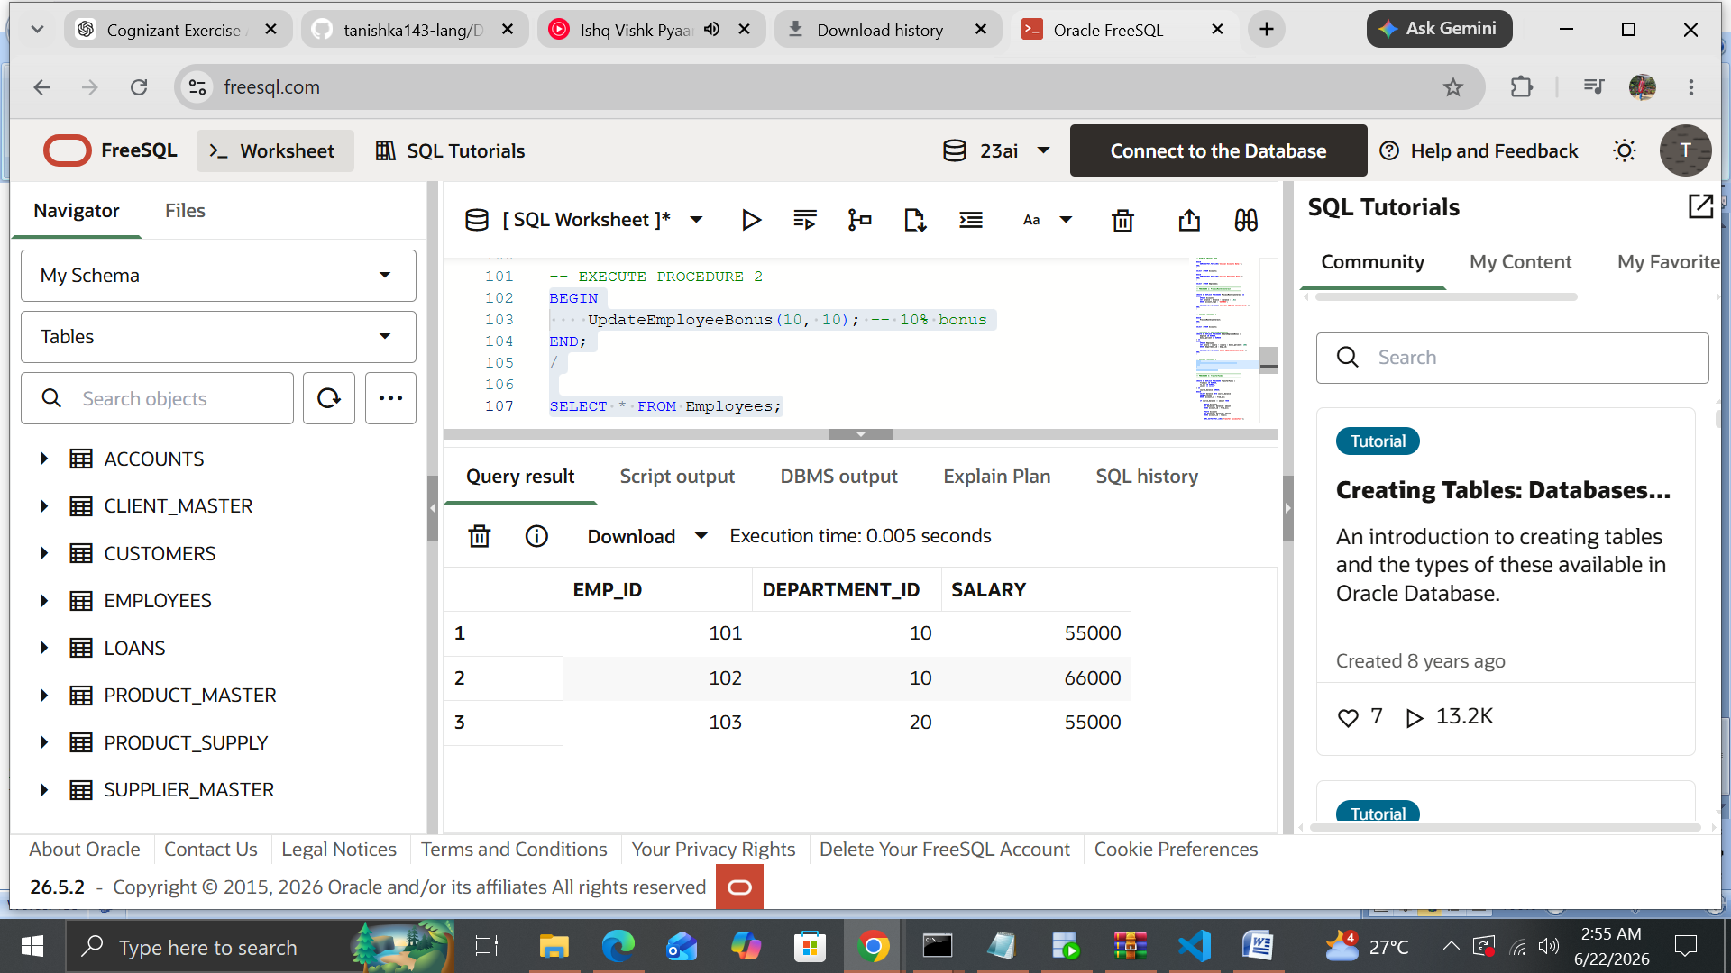

Scenario 3: Customers should be able to transfer funds between their accounts.
o Question: Write a stored procedure TransferFunds that transfers a specified amount from one account to another, checking that the source account has sufficient balance before making the transfer.
